|  |  |
| --- | --- |
| **Action** | **Keywords** |
| Compare two strings. | [StrComp](ms-help://MS.EXCEL.DEV.12.1033/HV01204169.htm) |
| Convert strings. | [StrConv](ms-help://MS.EXCEL.DEV.12.1033/HV01204170.htm) |
| Convert to lowercase or uppercase. | [Format](ms-help://MS.EXCEL.DEV.12.1033/HV01202659.htm), [Lcase](ms-help://MS.EXCEL.DEV.12.1033/HV01204130.htm), [Ucase](ms-help://MS.EXCEL.DEV.12.1033/HV01204183.htm) |
| Create string of repeating character. | [Space](ms-help://MS.EXCEL.DEV.12.1033/HV01204164.htm), [String](ms-help://MS.EXCEL.DEV.12.1033/HV01204171.htm) |
| Find length of a string. | [Len](ms-help://MS.EXCEL.DEV.12.1033/HV01204132.htm) |
| Format a string. | [Format](ms-help://MS.EXCEL.DEV.12.1033/HV01202659.htm) |
| Justify a string. | [LSet](ms-help://MS.EXCEL.DEV.12.1033/HV01202596.htm), [Rset](ms-help://MS.EXCEL.DEV.12.1033/HV01202615.htm) |
| Manipulate strings. | [InStr](ms-help://MS.EXCEL.DEV.12.1033/HV01204116.htm), <ms-help://MS.EXCEL.DEV.12.1033/HV01204131.htm>, [LTrim](ms-help://MS.EXCEL.DEV.12.1033/HV01204136.htm), [Mid](ms-help://MS.EXCEL.DEV.12.1033/HV01204139.htm), [Right](ms-help://MS.EXCEL.DEV.12.1033/HV01204156.htm), [RTrim](ms-help://MS.EXCEL.DEV.12.1033/HV01204136.htm), [Trim](ms-help://MS.EXCEL.DEV.12.1033/HV01204136.htm) |
| Set string comparison rules. | [Option Compare](ms-help://MS.EXCEL.DEV.12.1033/HV01202602.htm) |
| Work with ASCII and ANSI values. | [Asc](ms-help://MS.EXCEL.DEV.12.1033/HV01204078.htm), [Chr](ms-help://MS.EXCEL.DEV.12.1033/HV01204082.htm) |

**''''''''''''''''''''''''''''''''''''''''''''''''''''''''''''''''''''''''''''''''''''''''''''''''''''''''''''''''''''''''''''**

**''''''''''''''''''''''''''''''''''''''''''''''''''''''''''''''''''''''''''''''''''''''''''''''''''''''''''''''''''''''''''''**

**' InStr**

**''''''''''''''''''''''''''''''''''''''''''''''''''''''''''''''''''''''''''''''''''''''''''''''''''''''''''''''''''''''''''''**

**''''''''''''''''''''''''''''''''''''''''''''''''''''''''''''''''''''''''''''''''''''''''''''''''''''''''''''''''''''''''''''**

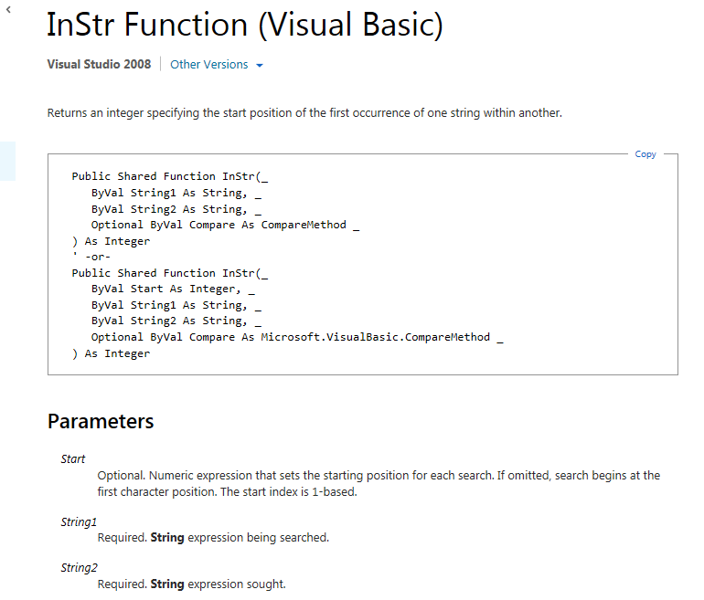

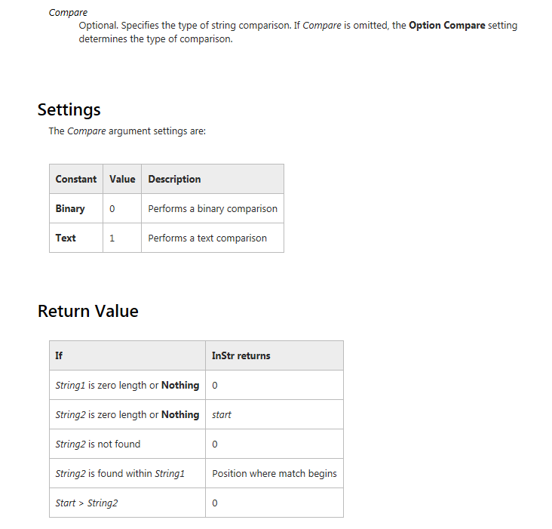

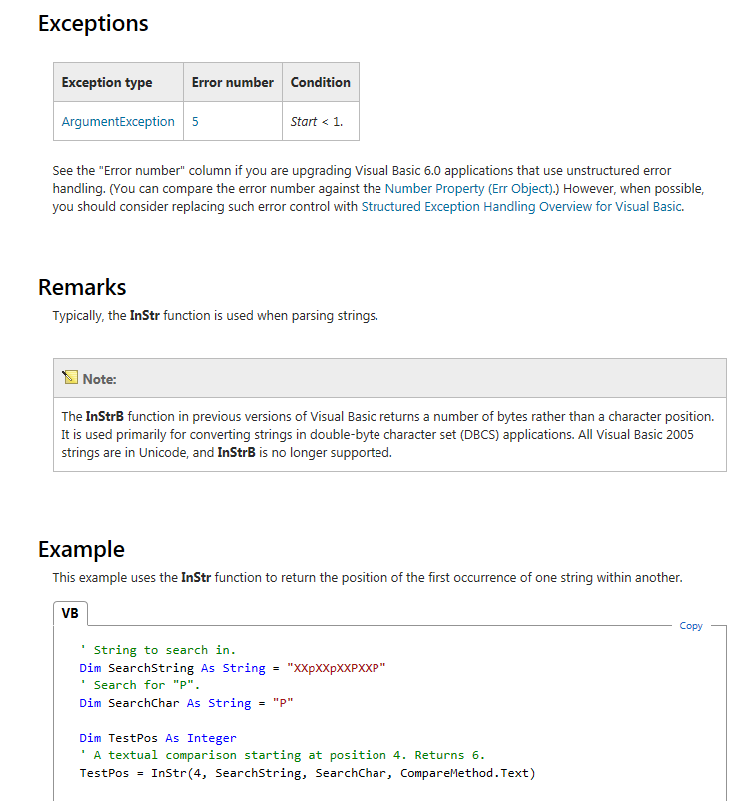

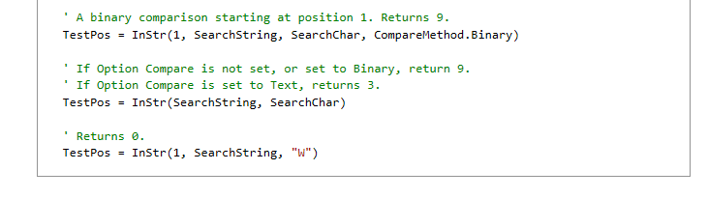

**''''''''''''''''''''''''''''''''''''''''''''''''''''''''''''''''''''''''''''''''''''''''''''''''''''''''''''''''''''''''''''**

**''''''''''''''''''''''''''''''''''''''''''''''''''''''''''''''''''''''''''''''''''''''''''''''''''''''''''''''''''''''''''''**

**' Mid**

**''''''''''''''''''''''''''''''''''''''''''''''''''''''''''''''''''''''''''''''''''''''''''''''''''''''''''''''''''''''''''''**

**''''''''''''''''''''''''''''''''''''''''''''''''''''''''''''''''''''''''''''''''''''''''''''''''''''''''''''''''''''''''''''**

